**Q1. If you have any, what are your choices for increasing the comparison between different figures on the same graph?**

Matplotlib provides a convenient method called subplots for increasing the comparison between different figures on the same graph. Subplots mean a group of smaller axes (where each axis is a plot) that can exist together within a single figure.

**Q2. Can you explain the benefit of compound interest over a higher rate of interest that does not compound after reading this chapter?**

Compound interest makes a sum of money grow at a faster rate than simple interest,because in addition to earning returns on the money you invest, you also earn returns on those returns at the end of every compounding period, which could be daily, monthly, quarterly or annually.

**Q3. What is a histogram, exactly? Name a numpy method for creating such a graph.**

A histogram is the best way to visualize the frequency distribution of a dataset by splitting it into small equal-sized intervals called bins.

Numpy has a built-**in numpy.histogram() function** which represents the frequency of data distribution in the graphical form.

***numpy.histogram(data, bins=10, range=None, normed=None, weights=None, density=None)***

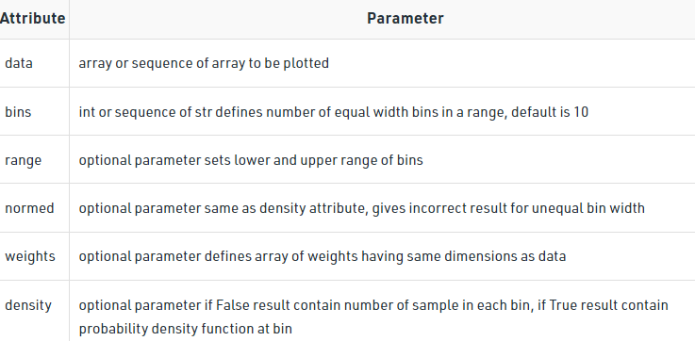

**Q4. If necessary, how do you change the aspect ratios between the X and Y axes?**

We can use figure(figsize=(10,8)) function inside the matplot.pyplot library which we scale down or up the graph.

**Q5. Compare and contrast the three types of array multiplication between two numpy arrays: dot product, outer product, and regular multiplication of two numpy arrays.**

* In regular multiplication values of same index get multiplied.
* In dot product there is row wise multiplication, row of one array with column of second array and so on.
* In outer multiplication every element of first array a1 will be multiply by every element of other array a2 such such the number of columns will be equal to the number of element in another array a2

**Q6. Before you buy a home, which numpy function will you use to measure your monthly mortgage payment?**

n order to calculate the monthly mortgage payment, you will use the numpy function .pmt(rate, nper, pv) where:

* rate = The periodic (monthly) interest rate
* nper = The number of payment periods (months) in the lifespan of the mortgage loan
* pv = The total value of the mortgage loan

**Q7. Can string data be stored in numpy arrays? If so, list at least one restriction that applies to this data.**

Yes we can store string data in arrays.

The **dtype** of any **numpy array that** contains string values **is the maximum length of any string present in the array**. Once set, it will only be able to store new string having length not more than the maximum length at the time of the creation. If we try to reassign some another string value having length greater than the maximum length of the existing elements, it simply discards all the values beyond the maximum length.

**import** numpy as np

# Create the numpy array

country **=** np.array(['USA', 'Japan', 'UK', '', 'India', 'China'])

# Print the array

print(country)

Lightbox

Here ,  the maximum length of any **string length element** in the given array is 5.

# Assign 'New Zealand' at the place of missing value

country[country **==** ''] = 'New Zealand'

# Print the modified array

print(country)

Lightbox

 ‘New Z’ has been assigned rather than ‘New Zealand’ because of the limitation to the length.

**Solution :** While creating the array assign the ‘object’ dtype to it. This lets you have all the behaviors of the python string.

# Create a numpy array

# set the dtype to object

country **=** np.array(['USA', 'Japan', 'UK', '', 'India', 'China'], dtype = 'object')

**Solution :** We will use the numpy.astype() function to change the dtype of the given array object.

# Change the dtype of the country

# object to 'U256'

country **=** country.astype('U256')

# Assign 'New Zealand' to the missing value

country[country **==** ''] = 'New Zealand'



The maximum length of the string that we can assign in this case after changing the dtype is 256.